Kaleb Wagner

Site Specification Document

CIS241

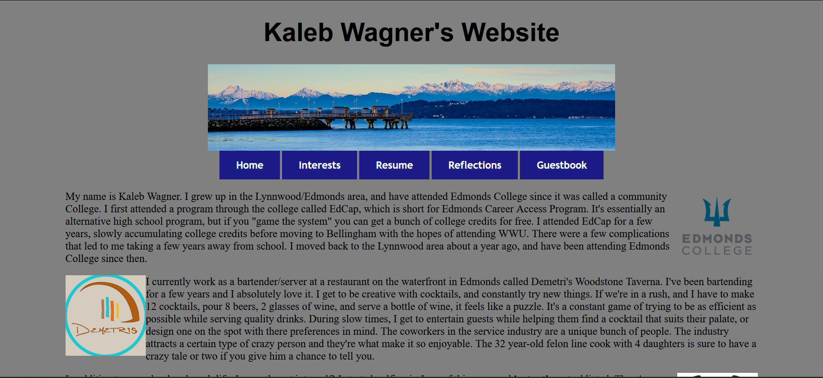

This is the homepage. It allows users to navigate to any of the other pages, and has a bit about who I am.

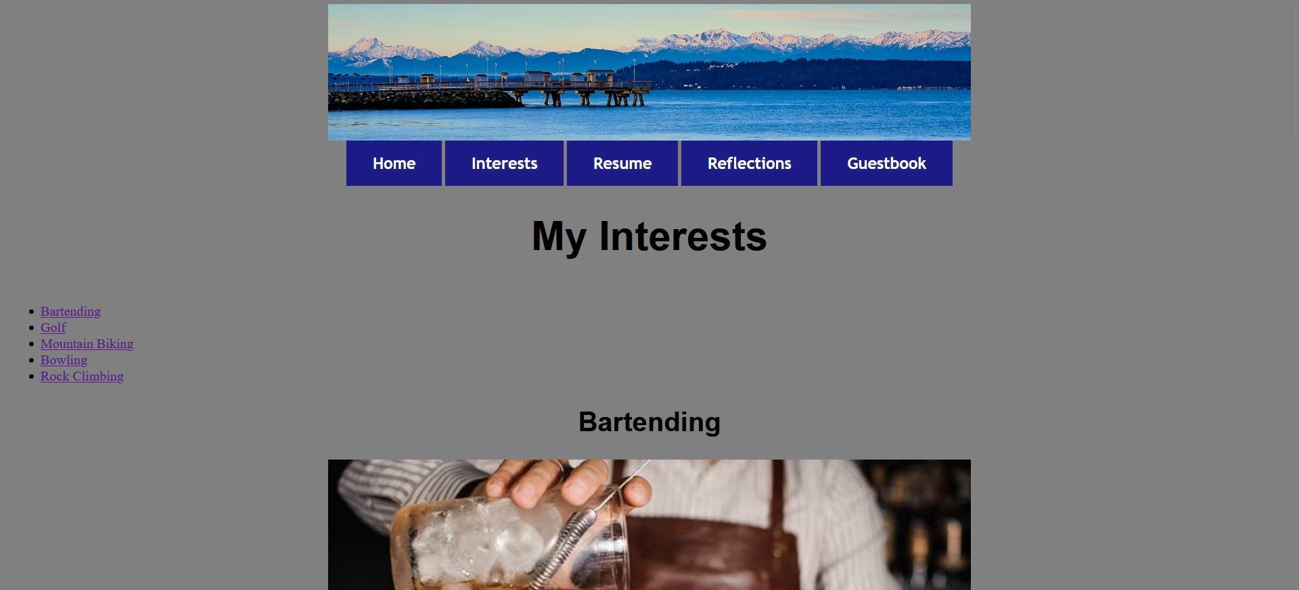

This is a page dedicated to my interests outside of school. I have a relevant image and blurb about each interest, and why I like it.

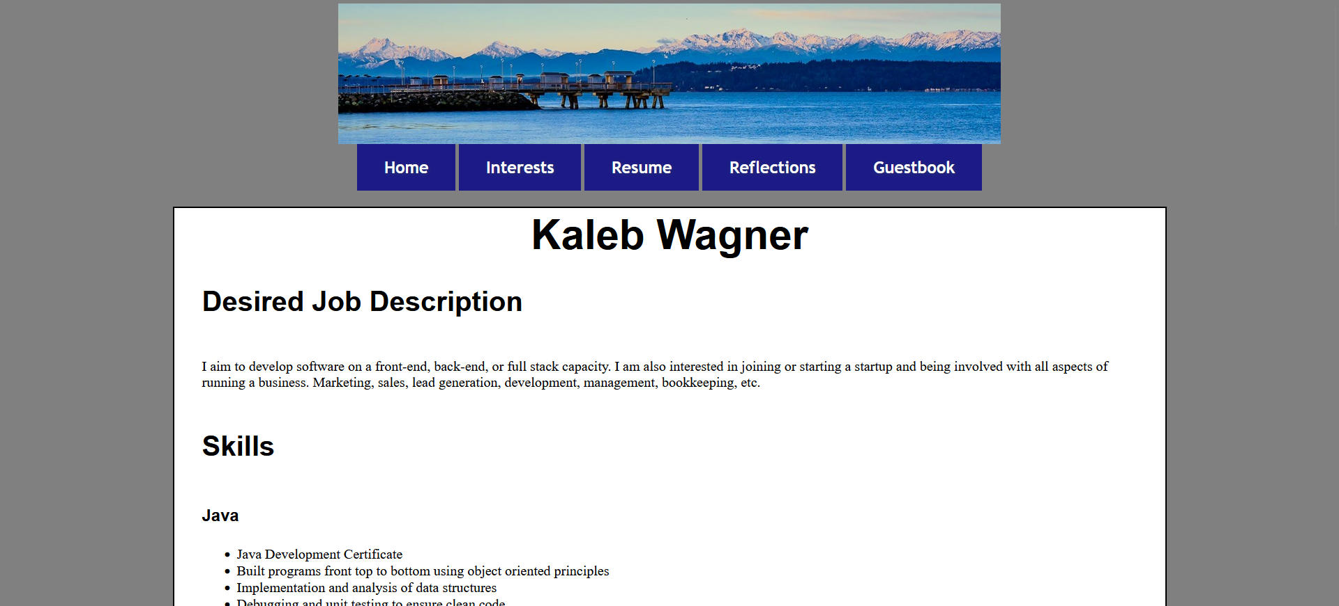

This is a digital version of my resume. It shows my desired job description, my skills, education, and work history.

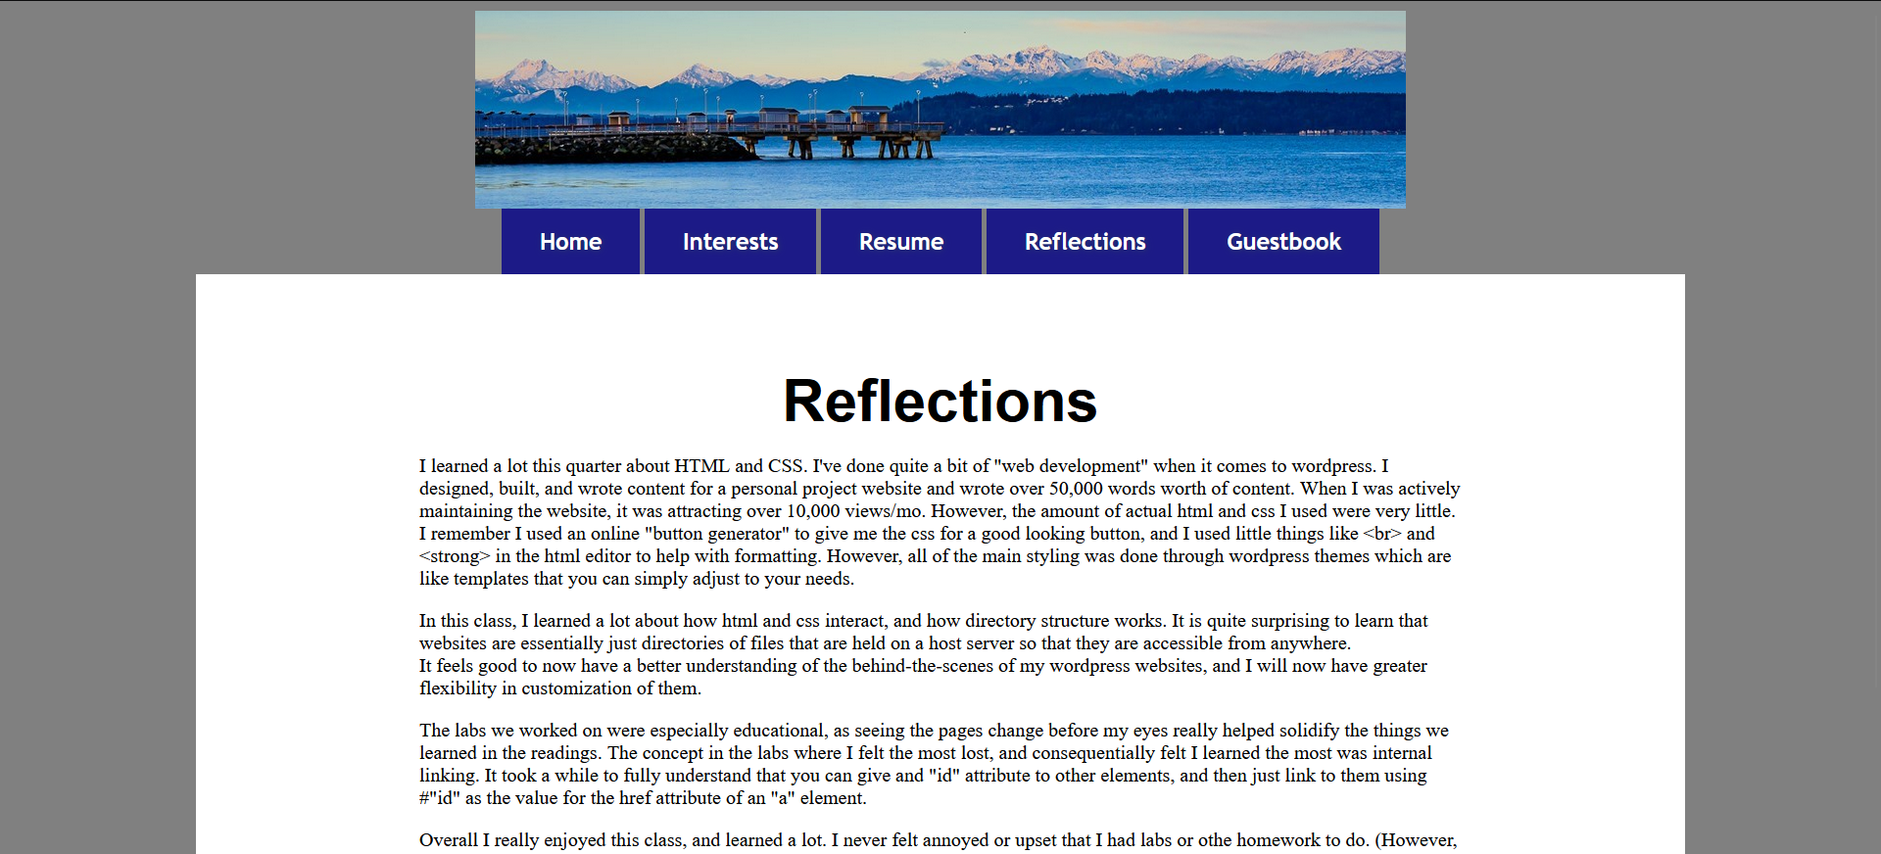

This page is my reflections on the CIS241 class. I explain a bit about what I learned and what I enjoyed, and what I found useful about the course.

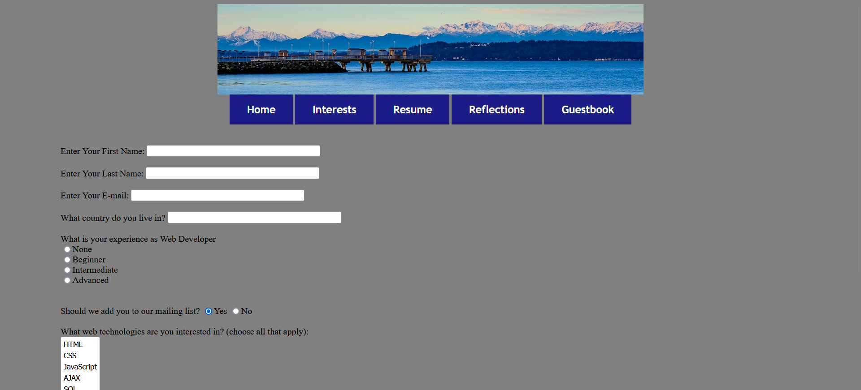

This page is a guestbook sign-in page. It has inputs for users to put information such as their name, email address, and which web technologies they are interested in.